

**PROJECT TITLE: SECURE CROWDFUNDING MOBILE MONEY SYSTEM**

A project report submitted to the School of Informatics and Innovative Systems in partial fulfillment of the requirements for the award of the

DEGREE OF

**BACHELOR OF SCIENCE**

*In*

**COMPUTER SECURITY AND FORENSICS**

*At*

JARAMOGI OGINGA ODINGA UNIVERSITY OF SCIENCE AND TECHNOLOGY

*Authors:*

**FRANK MACHOKA MBAKA** (I132/0872/2013)

**FELIX OTIENO ODHIAMBO** (I132/0566/2013)

DEC 2016

**Under the guidance of**

**Prof. Rodrigues**

DECLARATION

DECLARATION BY STUDENTS

This is to certify that the project report entitled **SECURE CROWDFUNDING MOBILE MONEY SYSTEM** being submitted by **FELIX OTIENO ODHIAMBO and FRANK MACHOKA MBAKA** havingregistration numbers **I132/0566/2013 and I132/0872/2013** respectively in partial fulfilment for the award of the Degree of Bachelor of Science in Computer Security and Forensics to Jaramogi Oginga Odinga University of Science and Technology is an original work and has not been submitted to any other University or Institute for the award of any Degree or Diploma.

FELIX OTIENO ODHIAMBO FRANK MACHOKA MBAKA

ADM. No: I132/0566/2013 ADM. No: I132/0872/2013

Signature…………………. Signature…………………….

Date………………………. Date………………………….

DECLARATION BY SUPERVISORS

This project report has been submitted for examination with our approval as the candidates’ University Supervisor.

PROF. A. J. RODRIGUES

Signature………………….

Date……………………….

DR. SAMUEL LIYALA

Signature…………………

Date………………………

DEDICATION

This project is dedicated to the almighty God who has given us life, good health and strength to pursue this course. We would also like to dedicate this work to our families and friends for having shown us love, patience and courage towards the completion of this project.

ACKNOWLEDGEMENT

We are indebted to Jaramogi Oginga Odinga University of Science and Technology for giving us a chance to pursue Bachelor of Science in Computer Security and Forensics. We wish to thank all our classmates and the SIIS staff for having contributed in formulation of ideas and for providing a suitable working environment towards the completion of this proposed work. In particular, we would like to thank Dr. Samuel Liyala for having contributed much towards the formulation of this project idea. We would also like to thank our supervisors Prof. A. J. Rodrigues and Dr. Samuel Liyala, for their constant guidance towards the development of this project.

ABSTRACT

Crowdfunding refers to behavior where individuals, rather than institutions, use digital technologies to make financial contributions to people, projects, or businesses in response to either financial or developmental commitments from those people, projects, or businesses. Secure Crowdfunding Mobile Money System is a project that its objective is to develop a system that will be integrated into mobile money platform (e.g. MPESA API) to allow project funders to contribute towards a good project idea of a seeker who lacks sufficient resources to implement the project idea. It is important to develop this project because it will seek to create a platform that will bridge the gap between viable project ideas and successful implementation of these projects so that good project ideas that can benefit individuals and the community at large cannot go into a waste. In order to successfully develop this project, we will employ the use of Software development methodology whereby we will use the Agile model and also carry out review of existing solutions in order to improve on areas of weaknesses apart from introduction of the new mode of payment in crowdfunding i.e. mobile money.

FOREWARD

This project is about crowdfunding which is a behavior where individuals, rather than institutions, use digital technologies to make financial contributions to people, projects, or businesses in response to either financial or developmental commitments from those people, projects, or businesses. We came up with this project idea so as to help bridge the gap between project ideas and successful implementation of these project ideas into successful projects.

TABLE OF CONTENTS

DECLARATION i

DECLARATION BY STUDENTS i

DECLARATION BY SUPERVISORS i

DEDICATION ii

ACKNOWLEDGEMENT iii

ABSTRACT iv

FOREWARD v

TABLE OF CONTENTS vi

LIST OF FIGURES x

LIST OF TABLES x

ACRONYMS AND ABBREVIATIONS xi

1. CHAPTER ONE 1

1.0 Introduction 1

1.1 Background Information 1

1.2 Problem Statement 1

1.3 Objectives 2

1.3.1 Main objective 2

1.3.2 Specific objectives 2

1.4 Justification of the Project 2

1.4.1 Benefits (Over existing solutions) 2

1.4.2 Assumptions 2

1.5 Scope 2

1.6 Stakeholder Matrix 3

Features of Proposed System 3

1.9 Quality plan 4

2. CHAPTER TWO 5

2.0 Literature Review 5

2.1 Existing Applications 5

2.1.1 Kickstarter 5

2.1.2 Indiegogo 5

2.1.3 RocketHub 6

2.1.4 Razoo 6

2.1.5 Crowdrise 6

2.1.6 PledgeMusic 6

2.1.7 Sellaband 6

3. CHAPTER THREE 7

3.1 Methodology 7

3.1.1 Agile System Development Methodology 7

3.1.2 Advantages of Agile 8

3.1.3 Disadvantages of Agile 8

3.2. Agile model Phases 8

3.2.1 System Planning 8

3.2.2 System Analysis 8

3.2.3 System Design 8

3.2.4 System Coding and Implementation 9

3.2.5 System Implementation and Testing 9

4. CHAPTER FOUR 10

4.1 SYSTEM ANALYSIS 10

4.2 System Requirements 10

4.2.1 Software requirement Specification 10

4.2.2 Hardware Requirement Specification 10

4.3 Functional requirements 11

4.4 Non-functional requirements 11

4.4.1 Reliability requirements 11

4.4.2 Usability requirements 11

4.4.3 Implementation requirements 11

4.5 TECHNOLOGIES USED 11

4.5.1 MySQL 11

4.5.2 Joomla 12

Advantages of Joomla 12

Disadvantages of Joomla 12

5. CHAPTER FIVE: 13

5.0 SYSTEM DESIGN 13

5.1 Architectural Design 13

5.2 Logical Design 14

5.2.1 Behavioral Description 14

Data Flow 14

Context Level DFD 14

Top Level DFD 15

5.2.2 Use Case Documentation 16

5.2.3 Process Flow 17

Activity Diagrams 17

Administrator Process 17

Fund Seeker Process 18

Sequence Diagram 19

Fund Seeker Sequence 19

Transaction Sequence 20

Entity Relationship Diagram 21

5.3 Physical Design 21

5.3.1 Homepage design 22

6. SYSTEM TESTING 23

6.1 Testing: 23

6.2 Testing Methodologies: 23

6.3 Levels of Testing 23

6.3.1 STLC (Software Testing Life Cycle) 23

Test Planning 23

Test Development 23

Test Execution 23

Result Analysis 23

Bug Tracing 23

6.4 Types of Testing 23

6.5 TCD (Test Case Document) 24

6.6 Test Cases: 24

Positive Test Cases 24

Negative Test Cases 24

SYSTEM IMPLEMENTATION 25

FINDINGS 26

RECOMMENDATION 27

CONCLUSION 28

APPENDIX 29

REFERENCES 29

USER MANUAL 31

3.2 Work plan 35

3.3 Cost/Benefit Analysis 36

5.3.2 Login page design 36

LIST OF FIGURES

Figure 1: SCMMS Stakeholder Matrix 3

Figure 2: Agile Model (Lyssa, 2010) 7

Figure 3: SCMMS Three tier Architecture 13

Figure 4: SCMMS Context Level DFD 14

Figure 5: SCMMS Top Level DFD 15

Figure 6: SCMMS General Use Case 16

Figure 7: SCMMS Administrator Activity diagram 17

Figure 8: SCMMS Fund Seeker Activity diagram 18

Figure 9: SCMMS Fund Seeker sequence diagram 19

Figure 10: SCMMS Transaction Sequence diagram 20

Figure 11: SCMMS Entity Relationship Diagram 21

Figure 12: SCMMS Homepage design 22

Figure 13: SCMMS Registration Screenshot 31

Figure 14: SCMMS Login Page Screenshot 32

Figure 15: SCMMS Project Wizard Screenshot 33

Figure 16: Administrator page Screenshot 34

Figure 17: SCMMS Mobile Money Process 35

Figure 18: SCMMS Work Plan 36

Figure 19: SCMMS Login Page Design 37

LIST OF TABLES

Table 1: SCMMS Positive Test Case 24

Table 2: Negative Test Case 24

Table 3: SCMMS Cost/Benefit Analysis 36

ACRONYMS AND ABBREVIATIONS

ASD - Adaptive Software Development life cycle

API - Application Programming Interface

CMS - Content management system

DFD - Data flow diagram

GB - Gigabyte

GHz - Gigahertz

ISO - International Organization for Standardization

MB - Megabyte

PIN - Personal Identification Number

RAM - Random Access Memory

RAD - Rapid Application Development

SDLC - Systems Development Life Cycle

SCMMS - Secure Crowdfunding Mobile Money System

1. CHAPTER ONE

1.0 Introduction

Crowdfunding refers to behavior where individuals, rather than institutions, use digital technologies to make financial contributions to people, projects, or businesses in response to either financial or developmental commitments from those people, projects, or businesses. There are four known types of crowdfunding namely:

1. Donation-based crowdfunding; funders do not seek returns from the project that they help to fund but are driven by a sense of responsibility to contribute for charitable causes.
2. Reward-based crowdfunding; allows fund seeker to promise non-monetary rewards to the funders, ranging from "pre-purchase" of products in development to souvenir and experience.
3. Debt-based crowdfunding; is the practice that a pool of funders collectively lend money to a seeker and expect the seeker to repay the loan with interests.
4. Equity-based crowdfunding; mainly designed for start-ups and small businesses to raise funds by offering shares to the funders.

Secure Crowdfunding Mobile Money System is a form of crowdfunding that implements donation-based and reward-based types of crowdfunding. Payments are made by the use of mobile money technology.

1.1 Background Information

SCMMS just like other crowdfunding system processes, begins with a seeker (registered user of the platform) initiating a request for funding by indicating the purpose of the request, the amount needed and the forms of returns or rewards for the funders. After the creation of a funding request, the platform will make necessary verifications of the project request before announcing the request publicly. The platform will keep the request open for a period of time during which potential funders (registered users of the mobile money platform) could commit their investments to fund the project via mobile money. In some cases, a project can provide a list of different rewards, and funders of the project can indicate their preference on rewards and investment amount. After the funding solicitation period ends, the invested funds (that met certain pre-specified conditions) will be transferred to the seeker. The rewards will then be paid to the funders at the agreed time. During this process, the platform also facilitates other additional exchange of information between funders and seekers.

1.2 Problem Statement

There are various project ideas that go into waste due to insufficient funds do develop and implement these project ideas that would benefit both individuals and the community at large. There is a concern to come up with a system that can easily be integrated into mobile money platform so that the public can fund good project ideas so that they can be implemented to achieve their benefits to both the individuals and the entire community.

1.3 Objectives

1.3.1 Main objective

To develop a system that will be integrated into mobile money platform (e.g. MPESA API) to allow project funders to contribute towards a good project idea of a seeker who lacks sufficient resources to implement the project idea.

1.3.2 Specific objectives

To develop a system that will provide a platform to enable seekers to post a project idea to be approved for funding.

To develop a system that will allow project funders to contribute via mobile money towards successful project ideas approved by administrators of the platform.

To develop a system that will maintain confidentiality, integrity and availability of the stakeholders’ data.

1.4 Justification of the Project

This project is necessary because it seeks to create a platform that will bridge the gap between viable project ideas and successful implementation of these projects so that good project ideas that can benefit individuals and the community at large cannot go into a waste i.e. fail to be accomplished. This project will be based on two types of crowdfunding namely: donations-based and reward-based.

1.4.1 Benefits (Over existing solutions)

1. It is easy to use since it only requires a mobile phone to contribute.
2. There are no additional charges incurred while making contribution.
3. It is fast and time saving.
4. It is less expensive to use and secure.

1.4.2 Assumptions

1. The public will be willing to contribute towards the project activities.
2. All members of the public have access to mobile phones.
3. All the seekers have access to Internet.

1.5 Scope

The system will be implemented in Kenya. SCMMS will enable the project funders who are well-wishers to contribute towards successful projects. The project will be developed from project conception and initiation to project close which will run from 17th October 2016 to 2nd December 2016 on a budget of 116, 200 Kenyan shillings. The stakeholders will be the fund seekers who will propose a project idea that requires funding upon approval, the platform administrators who form part of the team that approves the proposed ideas for funding, the project funders who are the mobile money subscribers who will be willing to contribute towards successful project ideas posted on the mobile money platform and the government.

1.6 Stakeholder Matrix

Figure 1 below shows the stakeholder matrix of SCMMS.



Figure 1: SCMMS Stakeholder Matrix

**1.7 Limitations of the project**

The project ideas can only be funded by mobile money subscribers only.

Features of Proposed System

**Fund Seeker**

1. User registration/login
2. Project submission wizard
3. User dashboard
4. Approved / rejected/ pending projects
5. Running projects- total funds raised, running period and closure
6. Project comments
7. Transactions
8. Ask question/ help
9. Terms of use
10. Privacy rights

**Administrator**

Create edit and approve projects.

Monitor capture and cancel projects

Categorize projects and make them featured

Setup a commission that will be sent to your system account

Finance

SCMMS payment module employs Customer to business, Business to customer, Business to business and Customer to customer.

1.9 Quality plan

The International Organization for Standardization (ISO) defines quality as “the degree to which a set of inherent characteristics fulfils requirements”. In order to achieve quality of our system we would use ISO: 9000:2000.

In order to achieve quality plan of SCMMS system, we refer to **ISO 9000** standard because it is a quality system standard that:

1. Is a three-part, continuous cycle of planning, controlling, and documenting quality in an organization
2. Provides minimum requirements needed for an organization to meet its quality certification standards
3. Helps organizations around the world reduce costs and improve customer satisfaction

2. CHAPTER TWO

2.0 Literature Review

European Crowdfunding Framework defines crowdfunding as a collective effort of many individuals who network and pool their resources to support efforts initiated by other people or organizations. Enabled by the Internet, crowdfunding utilizes the Internet (platforms) to initiate an open call for funding (Belleflamme et al. 2014). Unlike the traditional funding channels, this kind of model allows a project to engage a large number of potential funders by utilizing the Internet platform. In many instances, funding requirements are met with a majority of funders each contributed a small amount of funds to a project. Crowdfunders are not motivated solely by extrinsic rewards, whether they are in the form of products or financial return. Intrinsic motivations, such as fun to invest, curiosity, altruism, reciprocity, and identification, can also motivate the funders to invest in a project (Bretschneider et al. 2014). Participation in crowdfunding activities is social and investors derive community benefits (Belleflamme et al. 2014). Agrawal et al (2014) find that family members and friends are important source of funds in reward-based crowdfunding projects, which indicates social relationship could motivate funding behavior. Crowdfunders also care about whether the project they help to fund would succeed. Indeed, their collective judgements have been found to be a good indicator of project success (Herzenstein et al. 2011; Mollick & Nanda 2014). Ahlers et al. (2013) show that careful elaboration on the projects’ plan, such as financial roadmaps, risk factors and internal governance, reduces the perceived risks. There have been discussions about the similarity and differences among different crowdfunding models (Feldmann et al. 2013; Gonzalez & Mcaleer 2011; Hemer 2011; Lasrado & Lugmayr 2014; Pierrakis & Collins 2013), and their value proposition for funders and seekers (Haas et al. 2014). As multi-sided platforms, crowdfunding websites need to maintain its attractiveness to both seekers and funders by providing incentives (Naroditskiy et al. 2014), maintaining quality standards (Hu et al. 2014), and introducing high-performing entrepreneurs (Doshi 2014).

2.1 Existing Applications

2.1.1 Kickstarter

Probably the hottest crowdfunding site on the Internet is Kickstarter, which raised a total of $220 million from 61,000 launched projects so far. Thousands explore its listed projects every second waiting to give away their money to the project they think is most deserving! According to the guidelines, Kickstarter accepts all major kinds of creative projects but not for causes or awareness campaigns, charity or scholarships, and definitely not for vacations or a new digital camera.

2.1.2 Indiegogo

Indie is the short form of ‘independence’, so from the name you already know that this crowdfunding site is aimed to help you raise funds and make your personal project ‘go-go-go’ without any difficulty. The site’s layout is similar to Kickstarter so it’s easy to adapt to if you have tried Kickstarter. Unlike Kickstarter though, you can kick-start any project including donations for charity. Its "Backer Rewards" feature is known as "Perks" here.

2.1.3 RocketHub

It is definitely a popular station to fuel your project for launch. The site boasts a 3-step simple process to upload your project. You can then track the progress and status of your project. If you are just interested in crowdfunding, you can go for FuelPad, but RocketHub’s winning feature is the launchpad.

2.1.4 Razoo

The site focuses heavily on causes than profitable projects, but they do have a dedicated section for non-profit fundraising projects. Razoo divides fundraisers into 4 major categories: Nonprofits, Individuals, Corporations, and Foundations, and they each have their own benefits.

2.1.5 Crowdrise

Crowdrise specializes more on dealing with real world issues than fueling profitable creativity. They fund for animal welfare, arts, cultures, diseases, education, and even religion. It even labels itself as a platform that help raises money for Charity.

2.1.6 PledgeMusic

This one is a crowdfunding effort to bring in new talent into the music industry. The career of a music artist is an expensive one that requires major funding and publicity. PledgeMusic is one such crowdfunding site. Music-related sites are usually philosophical, with a hardcore user interface, but PledgeMusic is clearly an exception. Its interface looks persuasive and intuitive at the same time, just like the Kickstarter and Indiegogo!

2.1.7 Sellaband

Since its launch in 2006, Sellaband has coordinated recording sessions of more than 80 music artists, and, over $4,000,000 have been funded to music bands via the site. Different from its earliest version, Sellaband offers 100% freedom for your music creation: you are free to make the deal with any label, management company, or publisher without any limitations.

3. CHAPTER THREE

3.1 Methodology

The **Systems Development Life Cycle (SDLC)** is a framework for describing the phases involved in developing and maintaining information systems.

**Predictive life cycle** in which the scope of the project can be clearly articulated and the schedule and cost can be predicted; and **Adaptive Software Development (ASD)** **life cycle** in which requirements cannot be clearly expressed, projects are mission driven and component based, using time-based cycles to meet target dates.

We are going to use an ASD life cycle model called Agile System Development Methodology for developing SCMMS system.

3.1.1 Agile System Development Methodology

Most agile methods attempt to minimize risk by developing software in short time boxes called Iterations. Software development being essentially a human activity, will always have variations in processes and inputs and the model should be flexible enough to handle the variations. The following are the characteristics of Agile model that makes it suitable for SCMMS system development.

1. Iterative with short cycles enabling fast verifications and corrections.
2. Time bound iterative cycles.
3. Modularity at development process level.
4. People oriented.
5. Collaborative and communicative working style.
6. Incremental and convergent approach that minimizes risks and facilitates functional additions.

Figure 2 below shows the agile method that we used to develop SCMMS.

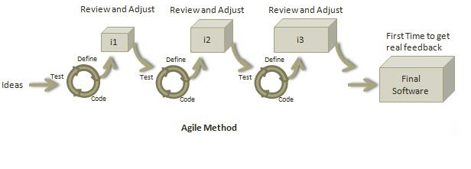

Figure 2: Agile Model (Lyssa, 2010)

3.1.2 Advantages of Agile

1. Customer satisfaction
2. Allows for changes to be made.
3. Deliver a working software frequently, ranging from a few weeks to a few months, considering shorter time-scale.
4. Promotes collaboration
5. Provides motivation between individual team members.
6. Allows face-to-face Conversation
7. Measure the Progress as per the Working Software.
8. Maintain Constant Pace
9. Monitoring - Pay regular attention to technical excellence and good design to enhance agility.
10. Simplicity - Keep things simple and use simple terms to measure the work that is not completed.
11. Review the Work Regularly

3.1.3 Disadvantages of Agile

1. Limited support for distributed development environments.
2. Limited support for subcontracting.
3. Limited support for developing large, complex software.
4. Limited support for development involving large teams.

3.2. Agile model Phases

3.2.1 System Planning

In planning phase, we identified the system requirements for the SCMMS system. This was first phase of the system and it entailed determining the necessary information that was required for the system to be fully operational and functional. The requirements that we captured was subjected to thorough scrutiny to determine the level of essence of it as well as eliminate the unwanted requirements. We did this based on the fact that though the requirements might have been raised by the target users, they might not be realistic or might not be so much important.

3.2.2 System Analysis

In this phase, we analyzed the features, advantages and limitations of existing crowdfunding systems. Other sources of information about system and the new requirements were also analyzed at this time. The important information from the planning phase was highly used in this phase, and the relevant information gathered from the users was analyzed for the design stage.

3.2.3 System Design

After the requirements were already analyzed, the design of the architectural, logical, physical and database design was carried out. It is in this phase that the flow charts, use case diagrams, sequence diagrams, dataflow diagrams and entity relationship diagrams were drawn to show flow of information and the activity diagrams were developed to show the relationship that will exist between one information flow and another.

3.2.4 System Coding and Implementation

After the design of the interfaces as well as the indication of the information flow through the Sequence diagrams and the flowcharts algorithms, the next step was to develop code that performed the hidden functionality of the system to realize the already set objectives. The code was developed highly depending on designs. The requirements specification document was referred to throughout the development process to ensure development was in line with the requirements and scope. A proper execution of the previous stages ensured an easier realization of this phase in the course of our development. Upon completion of the coding, the various components of the system were then integrated in to one system in order to function collectively as a single component.

3.2.5 System Implementation and Testing

System testing is done when development is complete and the system is ready for deployment. The testing phase come next to determine if the earlier intended objective have been realized. Testing was done based on whether completeness of the system and based on functional testing that determined whether the system is operating as intended. User testing was then carried out to ascertain that the users will be satisfied with SCMMS system based on usability, efficiency, effectiveness and security.

4. CHAPTER FOUR

4.1 SYSTEM ANALYSIS

Upon the completion of the Secure Crowdfunding Mobile Money System, there are a number of things that will be expected of it not only by the prospected users but also for the administrator of the system. These will therefore form the requirements of the Secure Crowdfunding Mobile Money System and will be broadly classified in to the system requirements, functional requirements and the Non-functional requirements.

4.2 System Requirements

4.2.1 Software requirement Specification

A set of programs associated with the operation of a computer is called software. Software is the part of the computer system, which enables the user to interact with several physical hardware devices.

The minimum software requirement specifications for developing this project are as follows:

Operating System: Windows 7,

Presentation layer: Joomla v3.4.x, crowdfunding API, php 5.5.x, fileinfo, php intl, jQUERY 1.9.x, cURL, fopen, bootstrap based template (Helix 3),prism library, wampserver v2.4, Mpesa/airtel/equitel api and browsers.

Database: MySQL 5.5.3+

Documentation Tool: Microsoft Office

4.2.2 Hardware Requirement Specification

The collection of internal electronic circuits and external physical devices used in building a computer is called the Hardware. The minimum hardware requirement specifications for developing this project are as follows:

Processor: Standard processor with a speed of 1.6 GHz or more

RAM: 256 MB RAM or more

Hard Disk: 20 GB or more

Monitor: Standard color monitor

Keyboard: Standard keyboard

Mouse: Standard mouse

4.3 Functional requirements

1. Security; to ensure confidentiality, integrity and availability
2. Administrative functions
3. Authentication
4. Authorization levels
5. External interfaces
6. Historical data
7. Legal and regulatory requirement
8. Transaction corrections, adjustments and cancellations

4.4 Non-functional requirements

4.4.1 Reliability requirements

The system must perform accurately towards the administrator request. For example, when the administrator saves the edited details of the user, after he reviews the details later, they must be changed according to the latest details that was updated. Moreover, the client is not allowed to view the details that the administrator has. Besides that, the login form will have validity check to ensure that only the authorized users gain access to the system.

4.4.2 Usability requirements

This system should be user-friendly and easy to use so that users can perform their tasks easily.

4.4.3 Implementation requirements

In implementing the system, it uses JOOMLA as the main tool. This forms the front-end.

At the back-end, the Apache and MYSQL will be synchronized and be used to maintain the information in the database. This is formed by the databases and other data stores.

Integrating the system with mobile money API.

4.5 TECHNOLOGIES USED

4.5.1 MySQL

We started out with the intention of using the MySQL database system to connect to our tables using our own fast low-level routines. This resulted in a new SQL interface to our database but with almost the same API interface as MySQL.

The following list describes some of the important characteristics of the MySQL Database Software that made us prefer it for SCMMS system to other databases.

**Internals and Portability**:

1. Written in C and C++.
2. Tested with a broad range of different compilers.
3. Works on many different platforms.
4. Uses GNU Automake, Autoconf, and Libtool for portability.
5. APIs for C, C++, Eiffel, Java, Perl, PHP, Python, Ruby, and Tcl are available.

**Security**: A privilege and password system that is very flexible and secure, and that allows host-based verification. Passwords are secure because all password traffic is encrypted when you connect to a server.

**MySQL Stability**

This section addresses the questions, “How stable is MySQL Server?” and, “Can I depend on MySQL Server in this project?” We identified MySQL to be compatible and stable with most of the platforms that SCMMS system will run on since MySQL Server design is multi-layered with independent modules.

4.5.2 Joomla

Joomla is a content management system (CMS) which connects your site and applications to a MySQli, MySQL or postgreSQL database in order to make content management and delivery easier on both the site manager and visitor. We picked on Joomla for SCMMS System due to the readily available resources it contains and due to the advantages listed below.

Advantages of Joomla

1. It is a full featured content management system.
2. Simple to understand and use.
3. It is less expensive to use and it is open source.

Disadvantages of Joomla

1. Difficult to install and setup.

5. CHAPTER FIVE:

5.0 SYSTEM DESIGN

5.1 Architectural Design

SCMMS system uses three tier architecture. Three tier architecture is a client-server architecture in which the functional process logic, data access, computer data storage and user interface are developed and maintained as independent modules on separate platforms. Three-tier architecture is a software design pattern and a well-established software architecture.

The three tiers in a three-tier architecture are:

**Presentation Tier**: Occupies the top level and displays information related to services available on a website. This tier communicates with other tiers by sending results to the browser and other tiers in the network.; **Application Tier**: Also called the middle tier, logic tier, business logic or logic tier, this tier is pulled from the presentation tier. It controls application functionality by performing detailed processing; and **Data Tier**: Houses database servers where information is stored and retrieved. Data in this tier is kept independent of application servers or business logic.

Figure 3 below illustrates the three tier architecture of SCMMS system.

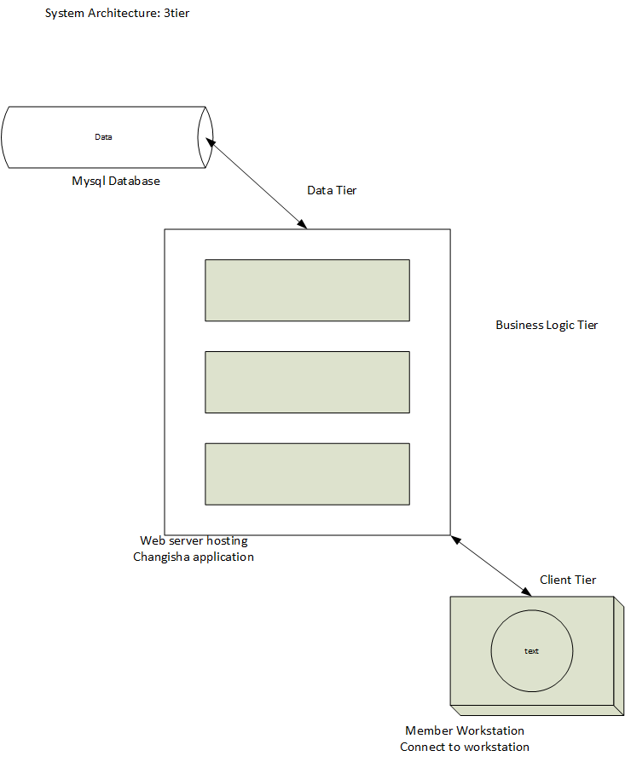

Figure 3: SCMMS Three tier Architecture

5.2 Logical Design

5.2.1 Behavioral Description

Data Flow

Context Level DFD

In the Context Level the whole system is shown as a single process.

Figure 4 below illustrates SCMMS context level DFD showing Inputs to the overall system and outputs from the overall system shown together with their destinations.

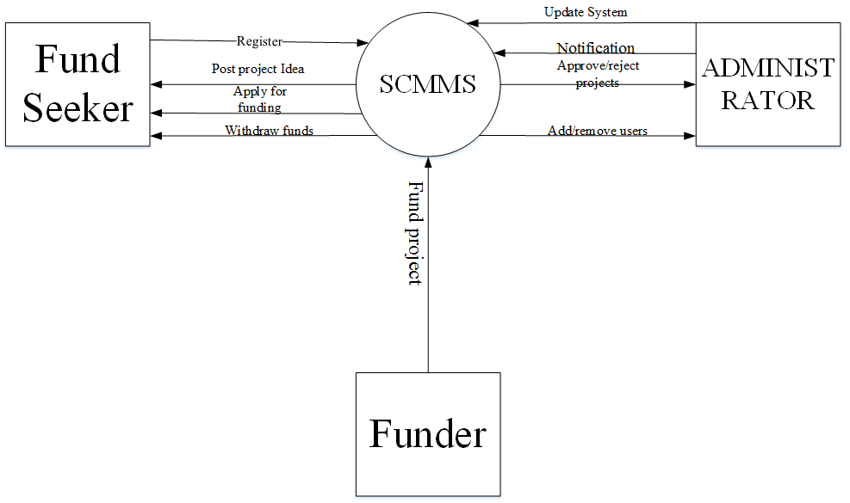

Figure 4: SCMMS Context Level DFD

Top Level DFD

The Top Level DFD gives the overview of the whole system identifying the major system processes and data flow. Figure 5 below shows SCMMS Top level DFD illustrating what the system does in more detail.

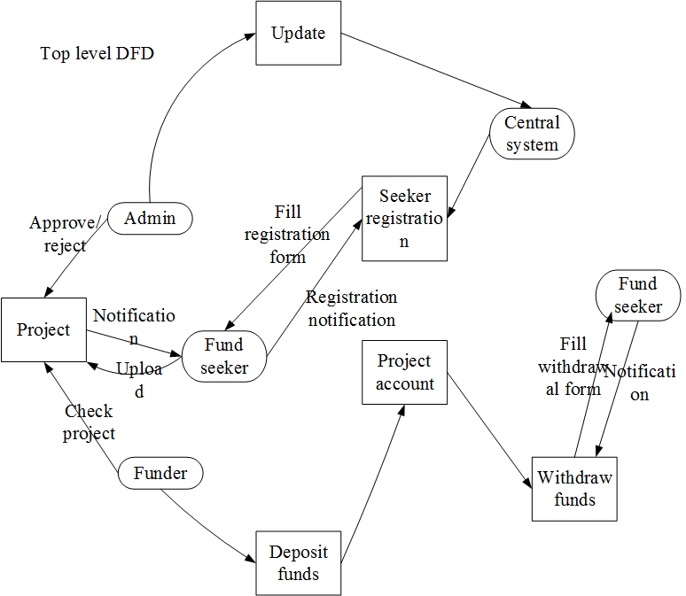

Figure 5: SCMMS Top Level DFD

5.2.2 Use Case Documentation

**Use Case Diagram**

A use case diagram is a diagram that shows a set of use cases and actors and relationships. Figure 6 below shows SCMMS general use case diagram illustrating fund seeker, administrator and funders relationships.

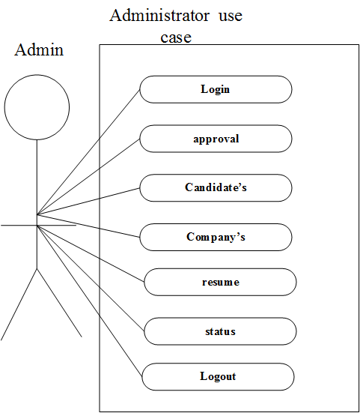

Figure 6: SCMMS General Use Case

5.2.3 Process Flow

Activity Diagrams

An activity diagram shows the flow from activity to activity. Figure 7 below shows SCMMS activity diagram showing the information flow of administrator.

Administrator Process

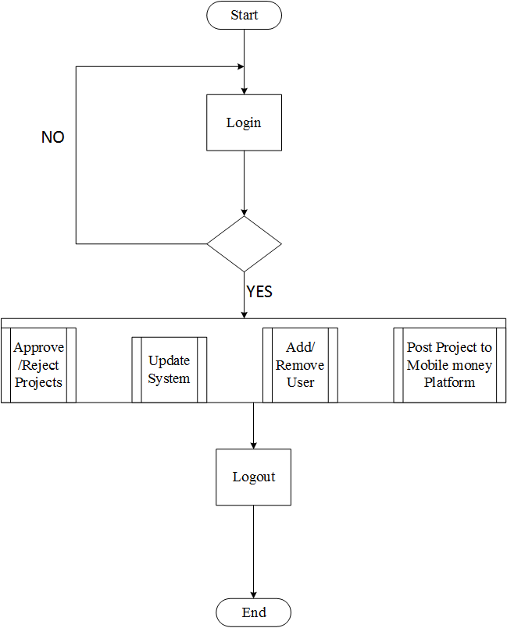

Figure 7: SCMMS Administrator Activity diagram

Fund Seeker Process

Figure 8 below shows SCMMS fund seeker activity diagram.

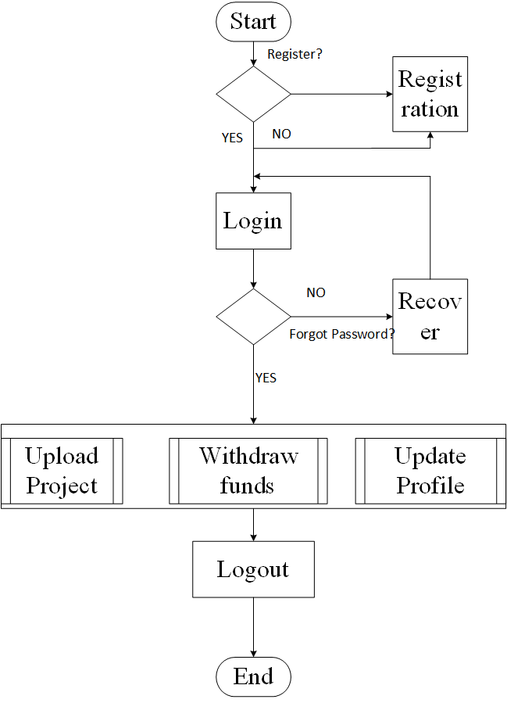

Figure 8: SCMMS Fund Seeker Activity diagram

Sequence Diagram

A sequence diagram is an interaction diagram that emphasizes the time ordering of messages. Graphically, a sequence diagram is a table that shows objects arranged along x-axis and messages, ordered in increasing time, along the y-axis.

Fund Seeker Sequence

Figure 9 below shows SCMMS fund seeker sequence diagram.

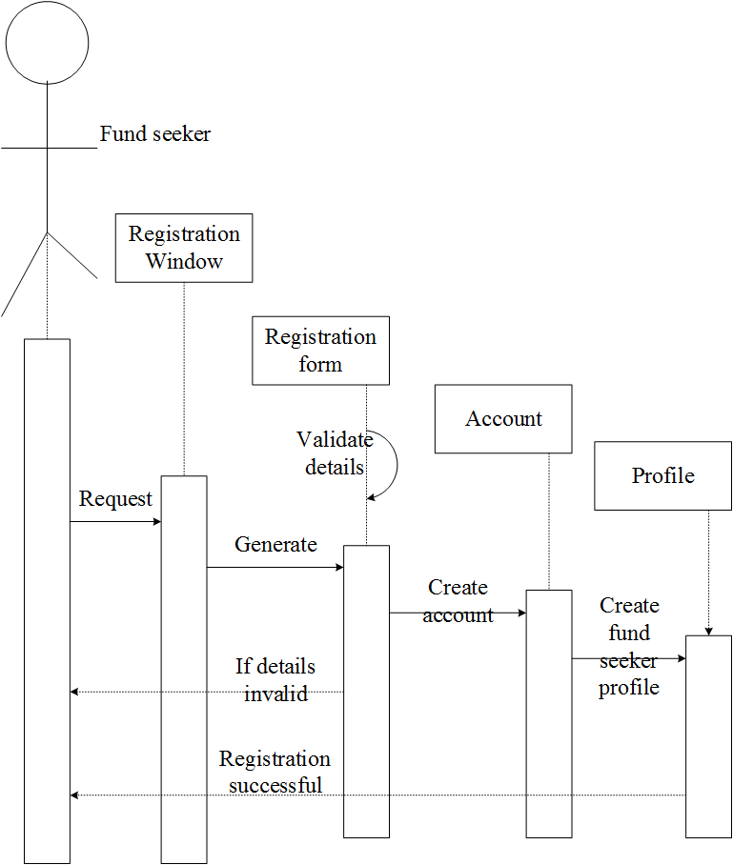

Figure 9: SCMMS Fund Seeker sequence diagram

Transaction Sequence

Figure 10 below illustrates SCMMS transaction sequence diagram.

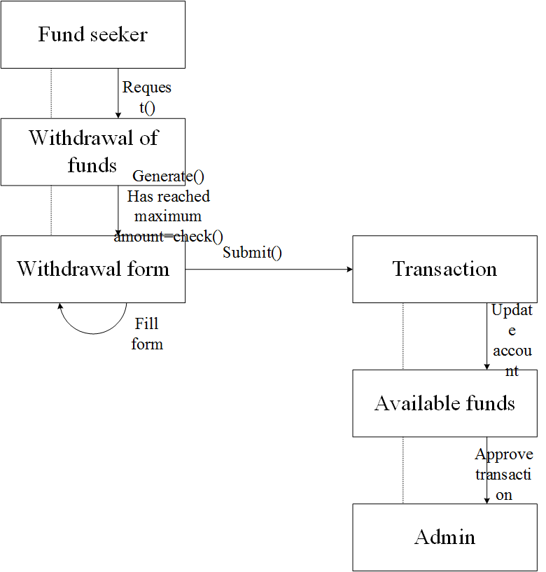

Figure 10: SCMMS Transaction Sequence diagram

Entity Relationship Diagram

It is a graphical representation of an information system that shows relationship between people objects, places, concepts or events within that system.

SCMMS uses the three main cardinal relationships: One-to-one (1:1), One-to-many (1: M), Many-to-many (M: N). Figure 11 below shows SCMMS entity relationship diagram.

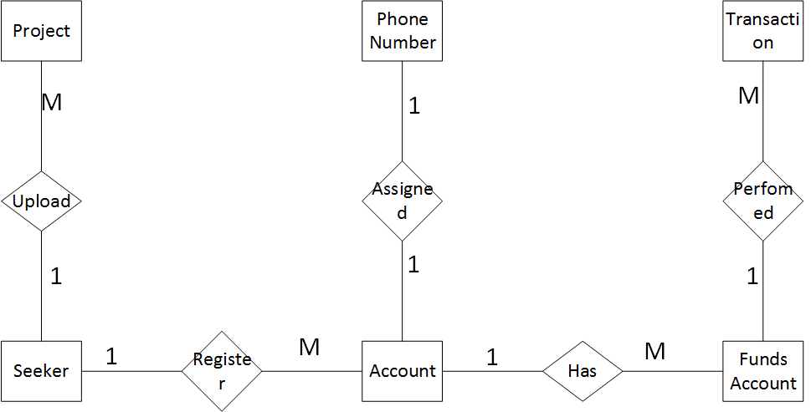

Figure 11: SCMMS Entity Relationship Diagram

5.3 Physical Design

Physical design relates to the actual input and output processes of the system. In physical design we decided on the following requirements about the SCMMS system. Physical design can be broken down into three sub tasks:

1. User interface
2. Data design
3. Process design.

5.3.1 Homepage design

Figure 12 below gives an overview of SCMMS homepage design.

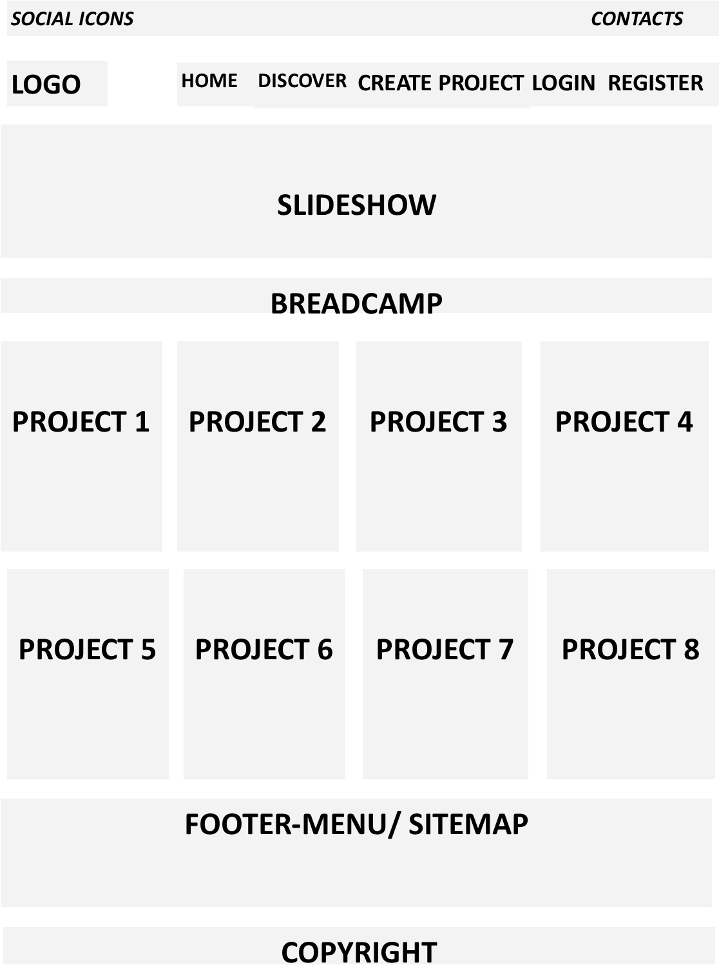

Figure 12: SCMMS Homepage design

6. SYSTEM TESTING

6.1 Testing:

Testing is defined as the process in which defects are identified, isolated, subjected for rectification and ensured that product is defect free in order to produce the quality product and hence customer satisfaction.

6.2 Testing Methodologies:

White box Testing: is the testing process in which tester can perform testing on an application with having internal structural knowledge. Usually The Developers are involved in white box testing. We as the developers of SCMMS applied white box testing as our testing methodology.

6.3 Levels of Testing

6.3.1 STLC (Software Testing Life Cycle)

Test Planning**:** While planning for testing of SCMMS system, we identifiedobjectives of the test, areas that needed to be tested, areas that were not to be tested, and Scheduling Resource Planning,

Test Development: In the test development we prepared a checklist (Test case Development) and the description of the test cases(Test Procedure preparation.)

Test Execution: Test execution phase of SCMMS involved implementation of test cases and observing the result of the test.

Result Analysis: Result analysis of testing SCMMS system contained: Expected value: behavior of the system; and Actual value: actual behavior of the system.

Bug Tracing**:** We collected all the failed cases and prepared related documents.

**Reporting:** The results of the test gave us the status of the system.

6.4 Types of Testing

**Smoke Testing**: We performed an initial test on SCMMS system for the availability of all the functionalities.

**Sanity Testing:** We then conducted an initial test on the system to check for the proper behavior of an application.

**Regression Testing:** During the project we carried out several tests on functionalities that were tested before whenever we made a change to the existing functionality.

**Adhoc Testing:** We performed an Adhoc test (positive and negative)to perform GUI testing.

**6.5 TCD (Test Case Document)**

**Test scope:**

This involved the areas of the system to be tested including homepage, fund seeker dashboard and projects dashboard.

**Test Scenario:**

Our test scenario for the system included when the fund seeker fills in the application form, upload documents and hit the quit button.

**Test Procedure:**

Positive testing, Negative testing using the corresponding GUI test cases, helped us in performing adhoc testing.

**6.6 Test Cases**:

Positive Test Cases**:** The positive flow of the functionality was considered, valid inputs were used for testing and expected value was positive to verify whether the requirements are justified. Table 1 below shows SCMMS positive test case.

|  |  |  |  |  |
| --- | --- | --- | --- | --- |
| Test case number | Description | Expected value | Actual value | Result |
| 1 | Check for all the features in  the screen | The screen must contain  all the features |  |  |
| 2 | Enter the valid username and password for fund seeker | It should accept |  |  |

Table 1: SCMMS Positive Test Case

Negative Test Cases**:** Must have negative perception and invalid inputs must be used for test.

Table 2 below describes SCMMS negative test case.

|  |  |  |  |  |
| --- | --- | --- | --- | --- |
| Test case number | Description | Expected value | Actual  value | Result |
| 1 | Try to modify the information in date and time | Modification should not  be allowed |  |  |
| 2 | Enter invalid data in to the job seeker login form | It should not accept invalid data, save should not allow |  |  |

Table 2: Negative Test Case

SYSTEM IMPLEMENTATION

The process of ensuring that the information system is operational and then allowing users to take over its operation for use and evaluation. Implementation of SCMMS include activities such as:

1. Training of end users how the whole system operates and the functionalities of the system
2. Completion of user documentation.
3. System changeover.
4. Evaluation of the system on regular intervals.

FINDINGS

Crowdfunding systems are faced by various risks that need to be addressed so that it can efficiently perform its main objectives of financing projects by the crowd either for free or for little rewards. These risks that pose a threat to crowdfunding platforms include:

1. **Fraud;** funds may be used for different purposes than what was initially disclosed, the creator may also portray an idea he/she doesn’t own. The fund seeker who has been deemed malicious may also use the campaign where he or she gains access to personal and financial records and use it to defraud the owner.
2. Many funders are average persons and might be ignorant on the processes that go into various projects since they are not subject matter experts.
3. Most funders tend to contribute small amount of money and thus are not bothered by the returns particularly in reward based crowdfunding.
4. Small companies and private companies that are probably not registered do not possess necessary documents such as business plans and legal documents hence making it difficult for funders o contribute towards a project especially in debt-based and equity crowdfunding.
5. Crowdfunding has little follow up mechanisms and hence there is no way for funders to follow up on how their money was used and neither can they follow up on promised rewards if a project owner chooses to dishonor their promises.
6. Tax laws governing E-commerce is not clearly defined since the funding can take place across borders thereby causing a conflict on whether rewards that acts as a source of finance should be taxed.

RECOMMENDATION

1. Many project ideas go into waste due to insufficient funds to carry out the project. Successful implementation of this system and its integration into the mobile money platform will help bridge the gap between project ideas and their successful implementation.
2. Implementation of SCMMS will aid in minimizing fraud by encrypting user data, ensuring multiple layers of security to avoid phishing.
3. Training of general public and users of the system and creation of awareness by organizing boot camps.
4. Putting down rules, laws and guidelines that one must fulfill in order to apply for funding e.g. a person applying for funding from the crowd need to be a member of a registered company with clearly defined time period, business plan and legal documents.
5. SCMMS would help to eliminate cross border conflicts since mobile money platform can be customized for a certain region of choice.
6. Creation of international laws to help govern E-commerce.

CONCLUSION

In conclusion, SCMMS is a crowdfunding system, which enables project fund seekers to make an application for funding, and then the administrator approves the project idea or reject the project idea based on a set down criteria and then published into the mobile money platform to allow funders to contribute towards the project idea. SCMMS is secure, fast and reliable since most people in Kenya have access to mobile phone thereby able to access mobile money services.

APPENDIX

REFERENCES

Agrawal, A., Catalini, C., & Goldfarb, A. (2014). Crowdfunding: Geography, social networks, and the timing of investment decisions (Working Paper).

Ahlers, G., Cumming, D., Günther, C., & Schweizer, D. (2013). Equity crowdfunding (SSRN Working Paper No. 2362340).

Belleflamme, P., & Lambert, T. (2014). Crowdfunding: Some empirical findings and microeconomic underpinnings (SSRN Working Paper No. 2437786). Retrieved October 17, 2016, from http://papers.ssrn.com/sol3/papers.cfm?abstract_id=2437786 *

Bretschneider, U., Knaub, K., & Wieck, E. (2014). Motivations for crowdfunding: What drives the crowd to invest in start-ups? Paper presented at Twenty Second European Conference on Information Systems, Tel Aviv 2014.

Doshi, A. (2014). Agent heterogeneity in two-sided platforms: Superstar impact on crowdfuding (SSRN Working Paper No. 2422111).

Feldmann, N., Gimpel, H., Kohler, M., and Weinhardt, C. (2013). Using crowd funding for idea assessment inside organizations: Lessons learned from a market engineering perspective. Proceedings of 2013 IEEE 3rd International Conference on Cloud and Green Computing, CGC 2013 and 2013 IEEE 3rd International Conference on Social Computing and Its Applications, SCA 2013, 525–530.

Gonzalez, L., & McAleer, K. (2011). Online social lending: A peak at US Prosper and UK Zopa. Journal of Accounting, Finance and Economics, 1(2), 26–41.

Haas, P., Blohm, I., & Leimeister, J. (2014). An empirical taxonomy of crowdfunding intermediaries.

Hemer, J. (2011). A snapshot on crowdfunding (Working Paper Firms and Region Nr. R2/2011, Fraunhofer ISI).

Herzenstein, M., Sonenshein, S., & Dholakia, U. M. (2011). Tell me a good story and I may lend you my money: The role of narratives in peer-to-peer lending decisions. Journal of Marketing Research, XVIII (Special Issue 2011), 138–149. doi: 10.1509/jmkr.48.SPL.S138 *

Hu, M., Li, X., & Shi, M. (2014). Product and pricing decisions in crowdfunding (SSRN Working Paper No. 2405552).

Joseph F., Rob G., Stephen T., 2013. TOTO Seminar on Crowdfunding: Past Research, Future Directions June 6, Department of Accounting Finance and Information Systems University College Cork

Lasrado, L. A., and Lugmayr, A. (2014). Equity crowdfunding-A finnish case study. Multimedia and Expo Workshops (ICMEW), 2014 IEEE International Conference on.

Lyssa A. (2010). Coaching Agile Teams: A Scrum Masters, Agile Coaches and Project Managers in Transition

Mollick, E. (2014). The dynamics of crowdfunding: An exploratory study. Journal of Business Venturing, 29(1), 1–16.

Naroditskiy, V., Stein, S., & Tonin, M. (2014). Referral incentives in crowdfunding. Bonn: IZA—Institute for the Study of Labor.

Pierrakis, Y., & Collins, L. (2013). Crowdfunding: A new innovative model of providing funding to projects and businesses (SSRN Working Paper No. 2395226).

USER MANUAL

**Front end**

**Step 1:** Create an account by filling in the registration form. Figure 13 below shows SCMMS registration screenshot.

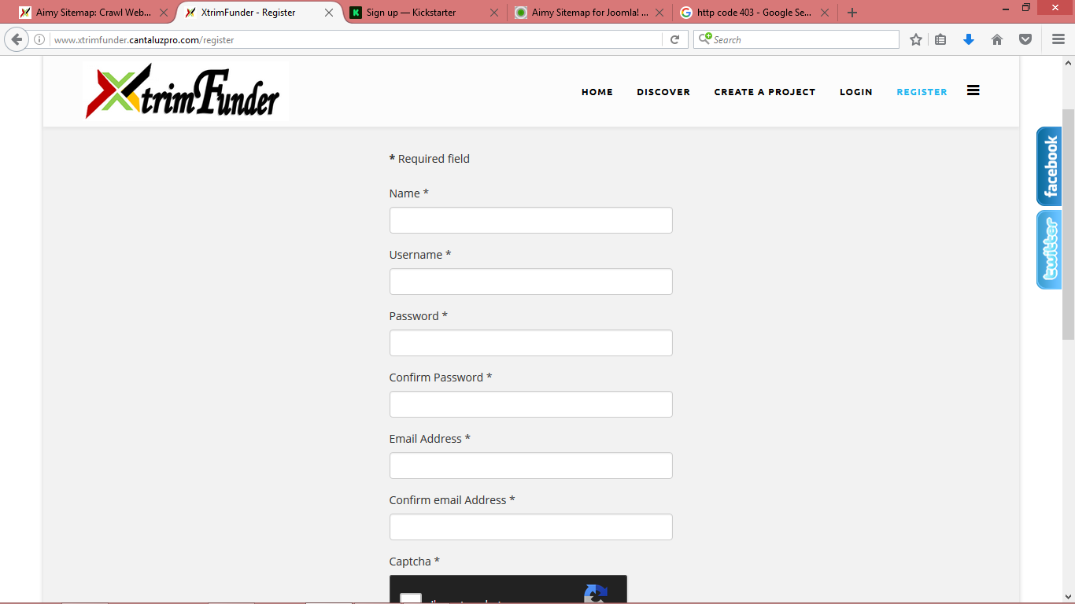

Figure 13: SCMMS Registration Screenshot

**Step 2:** Once account is created log in through the login tab. Figure 14 below shows SCMMS login page screenshot.

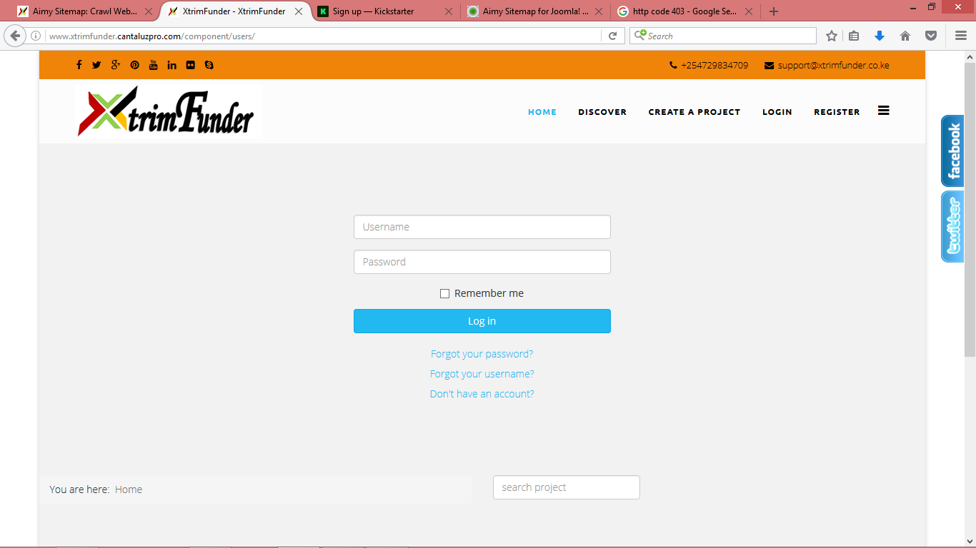

Figure 14: SCMMS Login Page Screenshot

**Step 3:** Once you are logged in, you have to verify your account via email notification sent to your email then you can proceed to edit your profile and then you are ready to apply for funding via the “create a project” pane specifying amount requested for funding, uploading project plan and supporting documents, and rewards if applicable and finally you publish it into the platform. Figure 15 below shows SCMMS project wizard screenshot.

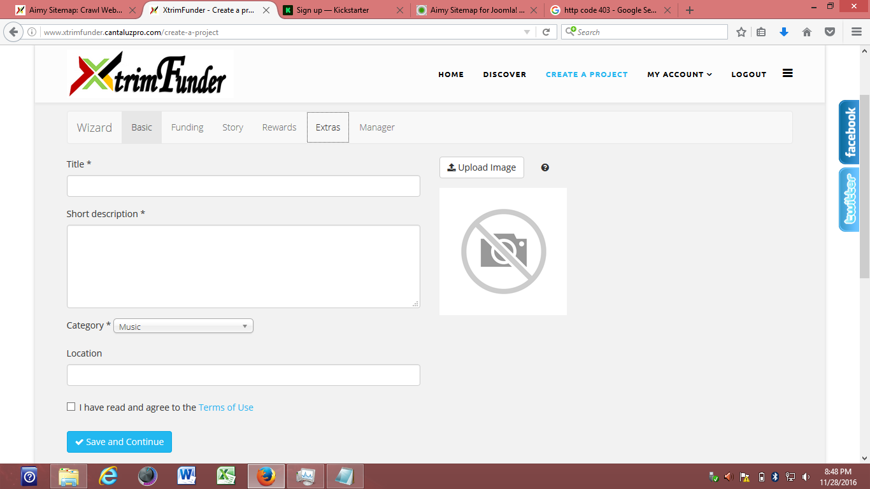

Figure 15: SCMMS Project Wizard Screenshot

**Back end**

**Step 4:** Once the project idea has been published by the fund seeker, it awaits approval by the administrator upon review of documents submitted by the approval panel. If it is approved, it is published into mobile money platform e.g. MPESA, Airtel or Equitel API.

Figure 15 below shows administrator page screenshot.

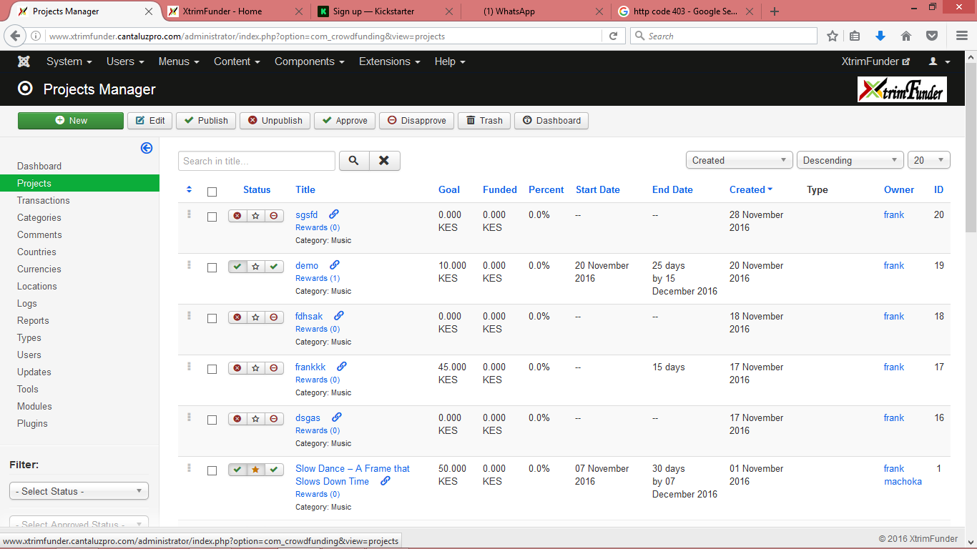

Figure 16: Administrator page Screenshot

**Mobile money platform (For contributors/ funders)**

**Step 5:** Once the project has been published into mobile money platform, it is ready for funding by the general public who have an interest in facilitating the project. For demonstration we use MPESA platform.

Figure 17 below illustrates SCMMS Mobile money process.

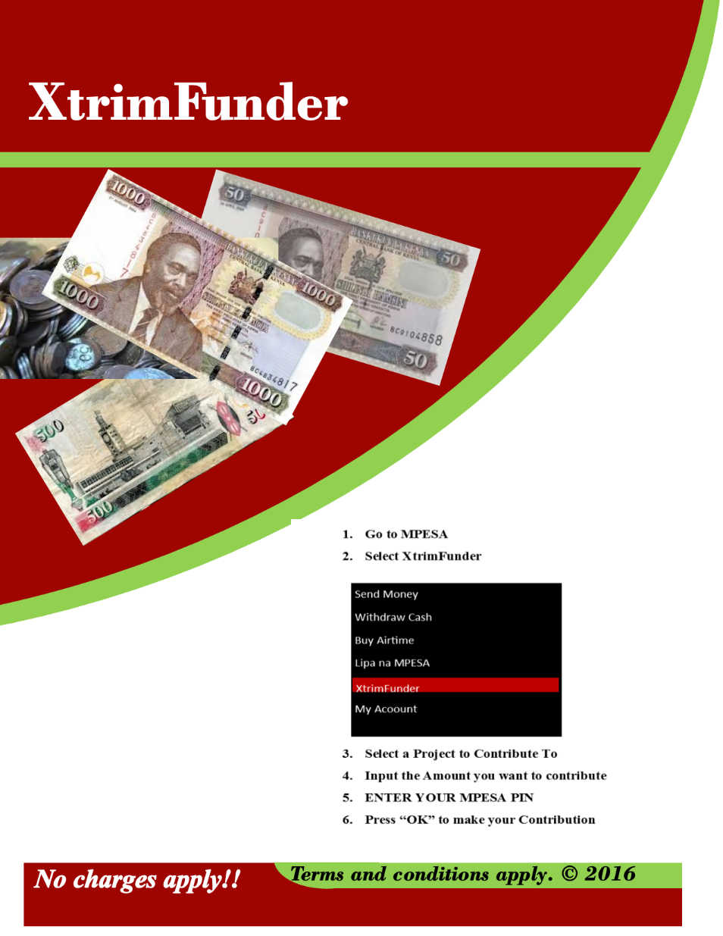

Figure 17: SCMMS Mobile Money Process

**Step 6:** Finally, if the project funding has reached the amount set and/or the time limit has elapsed, the fund seeker can withdraw the funds and start implementing his/her project.

3.2 Work plan

Figure 18 below shows SCMMS work plan.

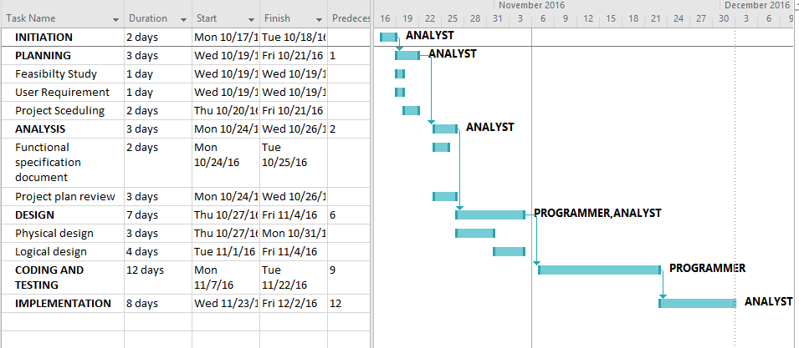

Figure 18: SCMMS Work Plan

3.3 Cost/Benefit Analysis

Table 3 below shows SCMMS Cost/Benefit Analysis.

|  |  |
| --- | --- |
| **ITEM** | **COST (KSHS)** |
| Hardware CPU | 60000 |
| Mobile Phone | 5000 |
| SIM Card | 100 |
| Data Bundles | 1000 |
| DVD’s | 100 |
| Implementation cost | 50000 |
| **TOTAL** | **116200** |

Table 3: SCMMS Cost/Benefit Analysis

5.3.2 Login page design

Figure 19 below shows SCMMS login page design.

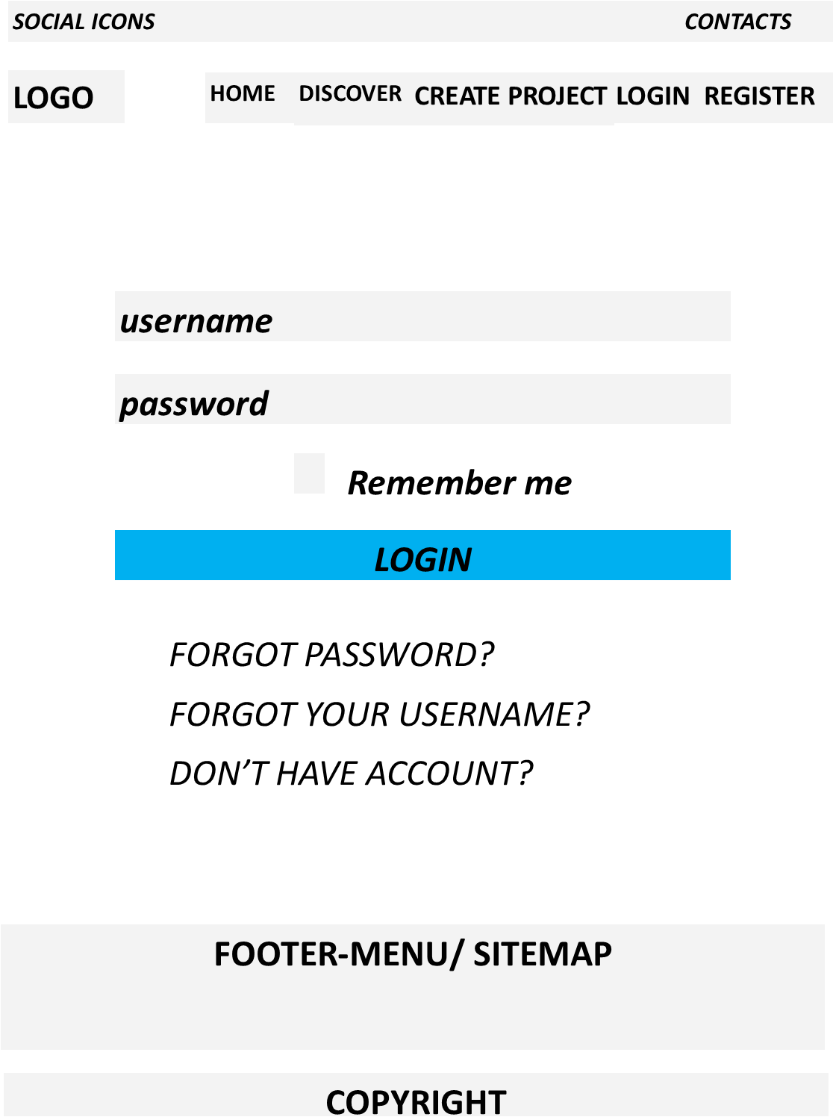

Figure 19: SCMMS Login Page Design